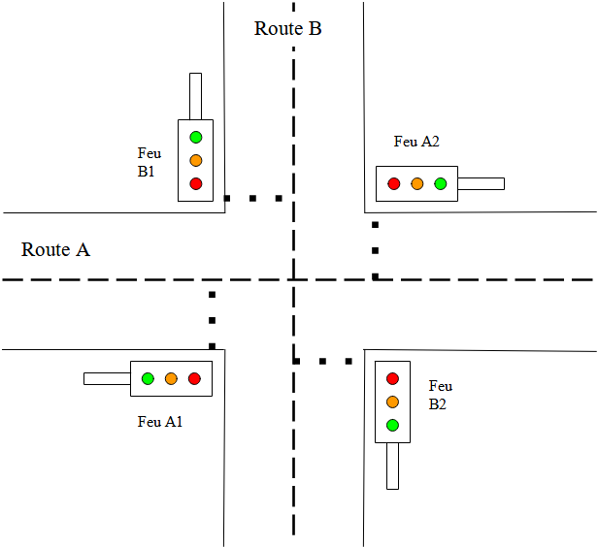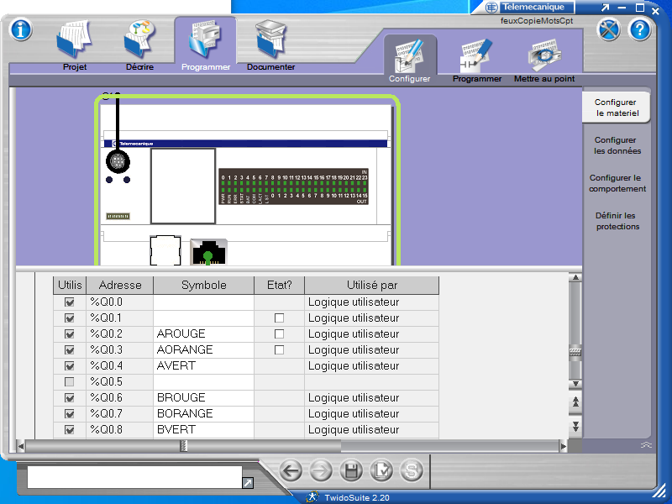

 |  |  |  |  |  |  |  |  | BV | BO | BR |  | AV | AO | AR
Etape |  | Q  15 | Q  14 | Q  13 | Q  12 | Q  11 | Q  10 | Q9 | Q8 | Q7 | Q6 | Q5 | Q4 | Q3 | Q2 | Q1 | Q0 | hex | dec
1 | AR BR | 0 | 0 | 0 | 0 | 0 | 0 | 0 | 0 | 0 | 1 | 0 | 0 | 0 | 1 | 0 | 0 | 0044 | 68 | AR BR
2 | AV BR | 0 | 0 | 0 | 0 | 0 | 0 | 0 | 0 | 0 | 1 | 0 | 1 | 0 | 0 | 0 | 0 | 0050 | 80 | AV BR
3 | AO BR | 0 | 0 | 0 | 0 | 0 | 0 | 0 | 0 | 0 | 1 | 0 | 0 | 1 | 0 | 0 | 0 | 0048 | 72 | AO BR
4 | AR BR | 0 | 0 | 0 | 0 | 0 | 0 | 0 | 0 | 0 | 1 | 0 | 0 | 0 | 1 | 0 | 0 | 0044 | 68 | AR BR
5 | AR BV | 0 | 0 | 0 | 0 | 0 | 0 | 0 | 1 | 0 | 0 | 0 | 0 | 0 | 1 | 0 | 0 | 0104 | 260 | AR BV
6 | AR BO | 0 | 0 | 0 | 0 | 0 | 0 | 0 | 0 | 1 | 0 | 0 | 0 | 0 | 1 | 0 | 0 | 0084 | 132 | AR BO

